SIMATS ENGINEERING
SAVEETHA INSTITUTE OF MEDICAL AND TECHNICAL SCIENCES
CHENNAI – 602105
Department of Computer Science and Engineering

ASSESSMENT TOOL 2 – Open Data Analysis

Course Code: | DSA0502 | Course Title: | Query Processing for Data Science
CO Assessed: | CO4 | Assessment: | Tool 2– Open Data Analysis
Weightage: |  | Total Marks:
CO4 Statement: Explore datasets using analytical techniques such as grouping, correlation detection, joining datasets, and extracting meaningful insights.
Student Name: | G Rajasekhar Reddy | Reg. No.: | 192424216
Section / Batch: | BTECH- AI & DS | Date of Submission: | 13/08/2026
Faculty In-charge: | Dr. B. Shyamala Gowri | Project Mode: | Individual Submission

Code of Conduct
I __G Rajasekhar Reddy(192424216)__ (Name / Reg No) certify that this submission is my original work and that I have adhered to all guidelines specified for this assessment. I understand that any violation of academic integrity rules will result in disciplinary action.
Signature: G Rajasekhar Reddy_____

3. Select any open education dataset containing student, school, examination, literacy, or enrollment information. Explore and analyze the data using grouping, comparison, correlation, outlier detection, and visualization techniques. Publish the analysis with appropriate charts and conclusions.
Aim:
To explore and analyze an open education dataset using grouping, comparison, correlation, outlier detection, and visualization techniques to identify meaningful patterns and insights from student performance data.

Program:
import pandas as pd
import matplotlib.pyplot as plt
import seaborn as sns
# Read dataset
df = pd.read_csv("student-mat.csv", sep=";")
# Display first 5 rows
print("FIRST 5 ROWS")
print(df.head())
# Dataset information
print("\nDATASET SHAPE")
print(df.shape)
# Grouping
print("\nAVERAGE FINAL GRADE BY GENDER")
print(df.groupby("sex")["G3"].mean())
# Comparison
print("\nAVERAGE FINAL GRADE BY SCHOOL")
print(df.groupby("school")["G3"].mean())
# Correlation
print("\nCORRELATION")
print(df[["studytime", "absences", "G1", "G2", "G3"]].corr())
# Outlier Detection
Q1 = df["G3"].quantile(0.25)
Q3 = df["G3"].quantile(0.75)
IQR = Q3 - Q1
lower = Q1 - 1.5 * IQR
upper = Q3 + 1.5 * IQR
outliers = df[
(df["G3"] < lower) |
(df["G3"] > upper)
]
print("\nNUMBER OF OUTLIERS")
print(len(outliers))
print("\nOUTLIERS")
print(outliers[["school", "sex", "G3"]])
# Bar Chart - Comparison
df.groupby("sex")["G3"].mean().plot(kind="bar")
plt.title("Average Final Grade by Gender")
plt.xlabel("Gender")
plt.ylabel("Average Final Grade")
plt.xticks(rotation=0)
plt.tight_layout()
plt.show()
# Scatter Plot - Correlation
plt.scatter(df["studytime"], df["G3"])
plt.title("Study Time vs Final Grade")
plt.xlabel("Study Time")
plt.ylabel("Final Grade")
plt.tight_layout()
plt.show()
# Box Plot - Outlier Detection
sns.boxplot(y=df["G3"])
plt.title("Final Grade Outlier Detection")
plt.ylabel("Final Grade")
plt.show()
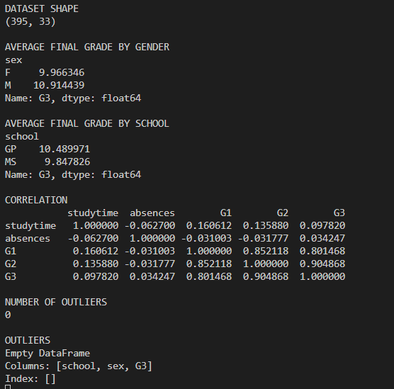
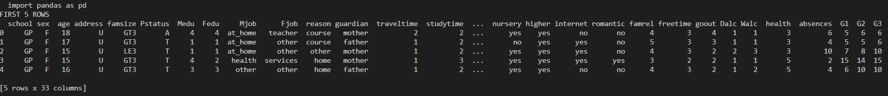
Output:

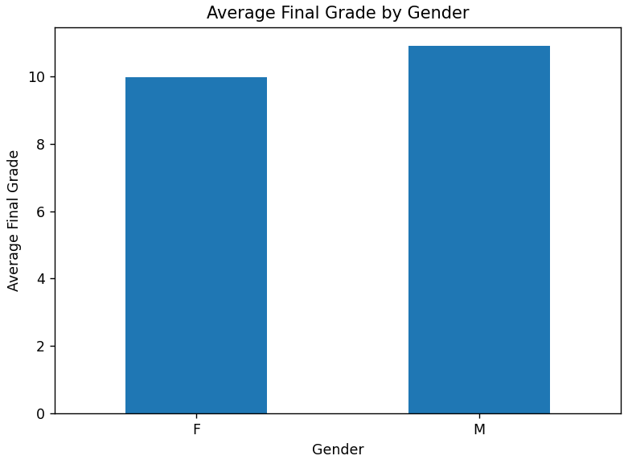
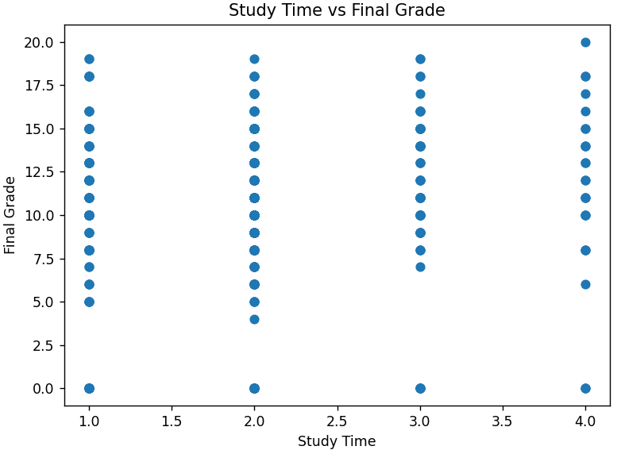

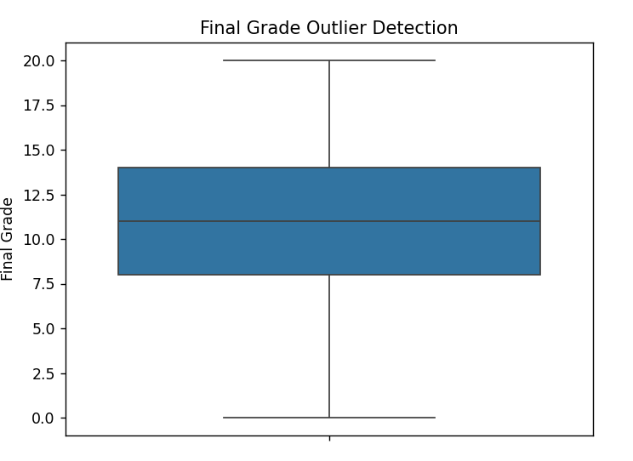
Conclusion:
The education dataset was successfully explored using Python and Pandas. Filtering, sorting, grouping, correlation analysis, and outlier detection were performed on the student performance data. The charts helped to compare student performance and understand relationships between different variables. The analysis provided meaningful insights into student academic performance.

10. Select any open social media or web dataset containing posts, comments, likes, shares, hashtags, keywords, or user activity. Analyze patterns, create groups, identify relationships and unusual observations, perform time-based analysis, and present the results using charts, word-based visualizations, interactive dashboards, and other suitable presentation tools.

Aim:

To select an open social media dataset containing posts, likes, comments, shares, topics, and user activity, and analyze the data using grouping, pattern analysis, correlation, outlier detection, time-based analysis, and visualization techniques.

Program:

import pandas as pd
import matplotlib.pyplot as plt
import seaborn as sns

# Read dataset
df = pd.read_csv("synthetic_social_media_engagement.csv")

print("FIRST 5 ROWS")
print(df.head())

print("\nDATASET SHAPE")
print(df.shape)

print("\nCOLUMN NAMES")
print(df.columns)

# Grouping
print("\nAVERAGE LIKES BY TOPIC")
print(df.groupby("topic")["likes"].mean())

# Comparison
print("\nTOP 10 POSTS BY LIKES")
print(df.sort_values("likes", ascending=False)[
["topic", "likes", "comments", "shares"]
].head(10))

# Correlation
print("\nCORRELATION")
print(df[["likes", "comments", "shares", "engagement_rate"]].corr())

# Outlier Detection
Q1 = df["likes"].quantile(0.25)
Q3 = df["likes"].quantile(0.75)

IQR = Q3 - Q1

lower = Q1 - 1.5 * IQR
upper = Q3 + 1.5 * IQR

outliers = df[
(df["likes"] < lower) |
(df["likes"] > upper)
]

print("\nNUMBER OF OUTLIERS")
print(len(outliers))

print("\nOUTLIERS")
print(outliers[["topic", "likes", "comments", "shares"]].head(10))

# Time-based analysis
df["post_date"] = pd.to_datetime(df["post_date"])

monthly_likes = df.groupby(
df["post_date"].dt.to_period("M")
)["likes"].sum()

print("\nMONTHLY LIKES")
print(monthly_likes)

# Bar Chart
df.groupby("topic")["likes"].mean().plot(kind="bar")

plt.title("Average Likes by Topic")
plt.xlabel("Topic")
plt.ylabel("Average Likes")
plt.xticks(rotation=45)
plt.tight_layout()
plt.show()

# Line Chart
monthly_likes.plot(kind="line", marker="o")

plt.title("Monthly Likes Trend")
plt.xlabel("Month")
plt.ylabel("Total Likes")
plt.tight_layout()
plt.show()

# Correlation Heatmap
sns.heatmap(
df[["likes", "comments", "shares", "engagement_rate"]].corr(),
annot=True
)

plt.title("Social Media Engagement Correlation")
plt.tight_layout()
plt.show()

# Outlier Box Plot
sns.boxplot(y=df["likes"])

plt.title("Likes Outlier Detection")
plt.ylabel("Likes")
plt.show()import pandas as pd
import matplotlib.pyplot as plt
import seaborn as sns

# Read dataset
df = pd.read_csv("synthetic_social_media_engagement.csv")

print("FIRST 5 ROWS")
print(df.head())

print("\nDATASET SHAPE")
print(df.shape)

print("\nCOLUMN NAMES")
print(df.columns)

# Grouping
print("\nAVERAGE LIKES BY TOPIC")
print(df.groupby("topic")["likes"].mean())

# Comparison
print("\nTOP 10 POSTS BY LIKES")
print(df.sort_values("likes", ascending=False)[
["topic", "likes", "comments", "shares"]
].head(10))

# Correlation
print("\nCORRELATION")
print(df[["likes", "comments", "shares", "engagement_rate"]].corr())

# Outlier Detection
Q1 = df["likes"].quantile(0.25)
Q3 = df["likes"].quantile(0.75)

IQR = Q3 - Q1

lower = Q1 - 1.5 * IQR
upper = Q3 + 1.5 * IQR

outliers = df[
(df["likes"] < lower) |
(df["likes"] > upper)
]

print("\nNUMBER OF OUTLIERS")
print(len(outliers))

print("\nOUTLIERS")
print(outliers[["topic", "likes", "comments", "shares"]].head(10))

# Time-based analysis
df["post_date"] = pd.to_datetime(df["post_date"])

monthly_likes = df.groupby(
df["post_date"].dt.to_period("M")
)["likes"].sum()

print("\nMONTHLY LIKES")
print(monthly_likes)

# Bar Chart
df.groupby("topic")["likes"].mean().plot(kind="bar")

plt.title("Average Likes by Topic")
plt.xlabel("Topic")
plt.ylabel("Average Likes")
plt.xticks(rotation=45)
plt.tight_layout()
plt.show()

# Line Chart
monthly_likes.plot(kind="line", marker="o")

plt.title("Monthly Likes Trend")
plt.xlabel("Month")
plt.ylabel("Total Likes")
plt.tight_layout()
plt.show()

# Correlation Heatmap
sns.heatmap(
df[["likes", "comments", "shares", "engagement_rate"]].corr(),
annot=True
)

plt.title("Social Media Engagement Correlation")
plt.tight_layout()
plt.show()

# Outlier Box Plot
sns.boxplot(y=df["likes"])

plt.title("Likes Outlier Detection")
plt.ylabel("Likes")
plt.show()

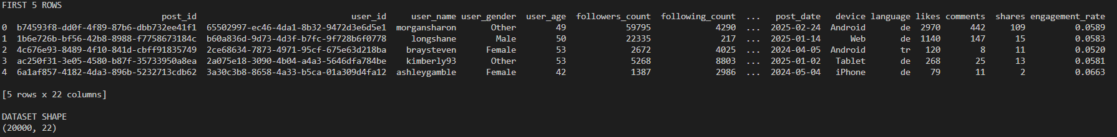
Output:
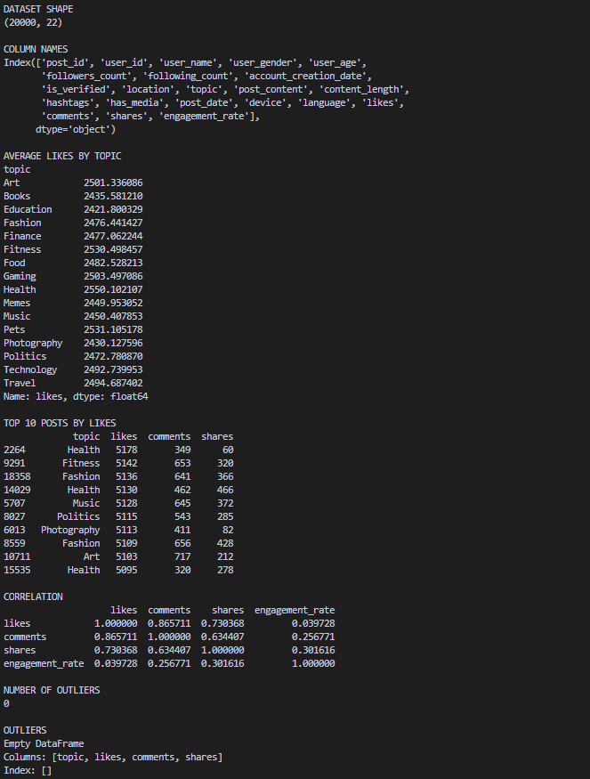

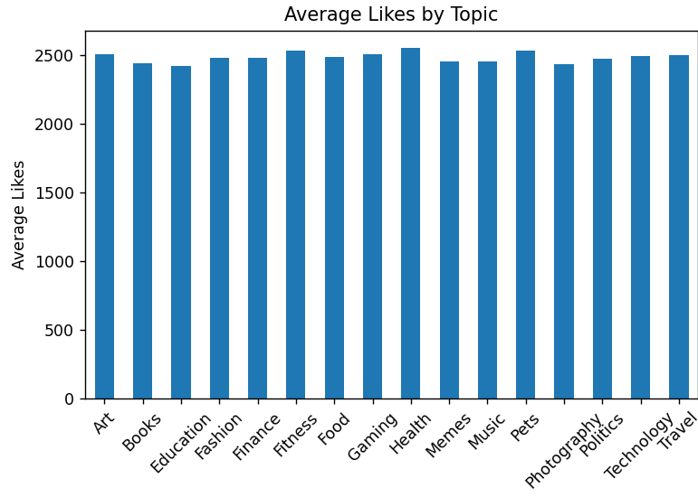
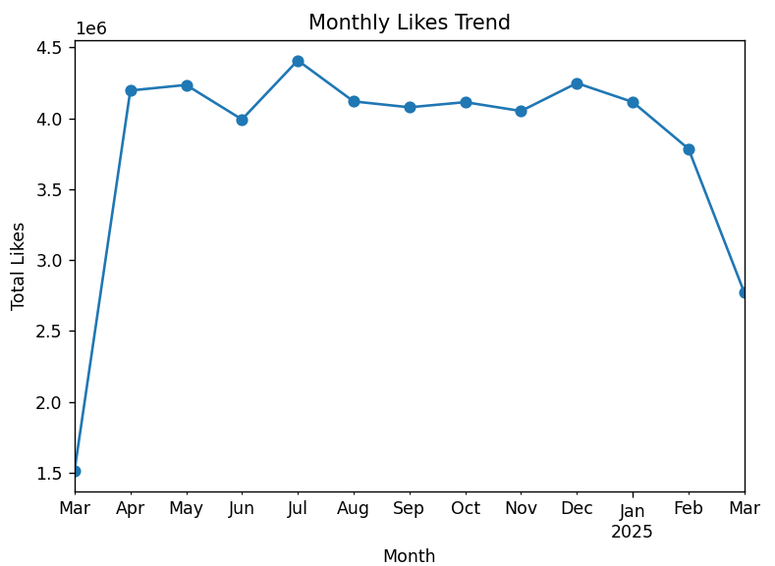
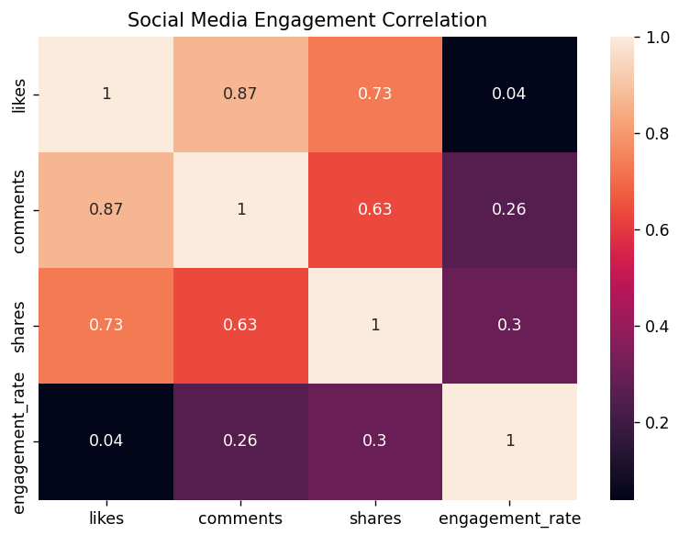
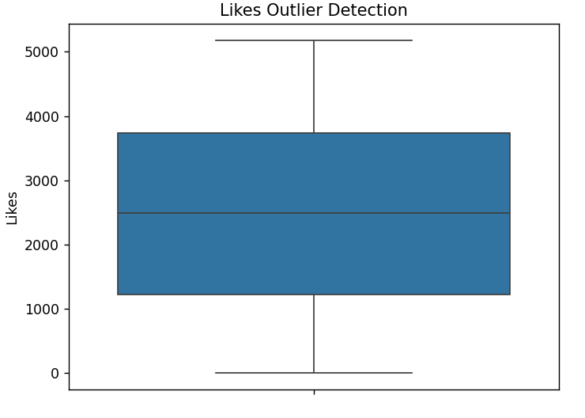

Conclusion:
The social media dataset was successfully analyzed using Python and Pandas. Filtering, sorting, grouping, correlation analysis, time-based analysis, and outlier detection were performed to identify important engagement patterns. The charts helped to visualize likes, comments, shares, and trends over time. The analysis provided meaningful insights into social media activity and user engagement.

